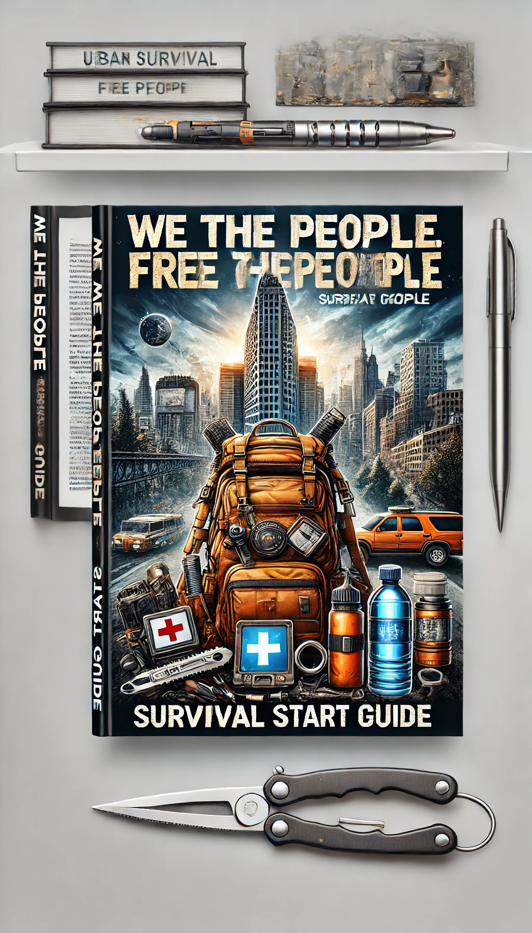

WTPFTP

Chapter 1: Basic Survival Mindset
Survival in the wilderness starts with the right mindset. Maintaining a positive mental attitude is crucial, as it can be the difference between life and death. When faced with a survival situation, it’s essential to remain calm and collected, even when circumstances are dire. This mental resilience allows you to assess your situation accurately, prioritize tasks, and make rational decisions. Practicing mindfulness and mental fortitude before venturing into the wild can prepare you for unexpected challenges, helping you stay focused and determined in the face of adversity.

Understanding the basics of survival psychology, such as the Rule of 3s, is fundamental. This rule states that you can survive three minutes without air, three hours without shelter in harsh conditions, three days without water, and three weeks without food. This hierarchy helps set priorities: securing breathable air, finding or constructing a shelter, locating and purifying water, and then sourcing food. By adhering to these principles, you can effectively manage your time and energy, increasing your chances of survival.

Chapter 2: Building Shelter
Shelter is one of the top priorities in a survival situation, providing protection from the elements, wild animals, and other environmental hazards. Various types of shelters, such as debris huts, lean-tos, and A-frame shelters, can be constructed using natural materials found in your surroundings. The type of shelter you build depends on the available resources, weather conditions, and the time you have. Learning how to construct these shelters beforehand is essential, as it can significantly improve your comfort and safety in the wilderness.

Choosing the right location for your shelter is just as important as the construction itself. A good shelter site should be dry, elevated, and away from potential hazards like falling trees or flash flood areas. Proximity to water sources is beneficial but should be balanced with the risk of flooding or attracting wildlife. By considering these factors, you can build a shelter that not only offers protection but also enhances your ability to rest and recover, crucial for maintaining your energy and morale in a survival scenario.

Chapter 3: Finding and Purifying Water
Water is essential for survival, and finding a reliable source is crucial in the wilderness. Natural indicators such as green vegetation, animal tracks, and geographical features can guide you to water. However, not all water sources are safe to drink from directly. Contaminated water can lead to severe health issues, so it’s important to know how to purify it. Boiling water is the most reliable method, killing pathogens that cause diseases. If boiling is not an option, filtration systems or chemical treatments can be used to make water safe for consumption.

DIY water filters can also be made using natural materials. A simple filter can be constructed with a container, charcoal, sand, and gravel, which helps remove impurities and improves water clarity. Collecting rainwater, if possible, is another safe method. Understanding these techniques ensures you have access to clean water, which is vital for hydration, cooking, and hygiene, significantly increasing your chances of survival.

Chapter 4: Foraging for Food
Foraging for food in the wild involves identifying and harvesting edible plants, fruits, nuts, and fungi. Knowledge of local flora is essential to avoid poisonous species. Many edible plants have toxic look-alikes, so it's crucial to learn how to distinguish them. Books on local plant life or mobile apps can be valuable resources. Foraging can provide essential nutrients, but it requires careful attention and some prior knowledge to ensure safety and effectiveness.

Trapping, hunting, and fishing are other critical skills for obtaining food in the wild. Simple traps and snares can be set up to catch small game, while basic hunting techniques can help you capture larger animals. Fishing can be done with improvised tools or makeshift fishing lines. Learning these skills before an emergency situation arises is crucial, as they require practice and patience. These methods can supplement foraged food, providing a balanced diet that supports sustained energy and health.

Chapter 5: Fire craft
Fire is a critical component of survival, providing warmth, a means to cook food, purify water, and signal for help. Starting a fire can be challenging, especially in wet or windy conditions, but mastering various fire-starting techniques can increase your chances of success. Methods include using a bow drill, flint and steel, or even focusing sunlight with a magnifying glass. Knowing how to find or create tinder, kindling, and fuel is equally important, as these materials sustain your fire.

Maintaining and using a fire effectively requires knowledge and skill. Building a proper fire lay, such as a teepee or log cabin structure, helps the fire burn more efficiently. Fire safety is paramount to prevent wildfires and protect yourself from burns. Once established, a fire can be used for cooking, boiling water, and providing light and warmth. It also serves as a powerful psychological boost, offering comfort and a sense of security in the wilderness.

Chapter 6: Navigation and Signaling
Navigating in the wilderness without modern tools can be daunting, but basic skills can guide you to safety. Using a map and compass is fundamental, yet natural navigation techniques can also be effective. Observing the position of the sun, stars, and natural landmarks like rivers and mountain ranges helps determine your direction. Understanding these methods allows you to orient yourself and move towards your desired destination, whether it's to find help or return to a known location.

Signaling for help is crucial if you are lost or injured. Visual signals, such as creating large ground symbols, using mirrors to reflect sunlight, or starting a smoky fire, can attract attention from rescuers. Auditory signals, like whistles or shouts, should follow the international distress signal pattern: three short bursts, repeated at regular intervals. Modern technology, like personal locator beacons, can also be lifesaving. Knowing these techniques increases your chances of being found and rescued.

Chapter 7: First Aid in the Wilderness
First aid knowledge is essential for handling injuries and illnesses in the wilderness. A well-stocked first aid kit should include bandages, antiseptics, pain relievers, and other basic medical supplies. Knowing how to use these items and performing basic first aid procedures can stabilize injuries until professional help is available. Treating cuts, burns, fractures, and sprains promptly prevents complications and promotes healing, ensuring you remain capable of navigating and surviving.

Dealing with extreme weather conditions, such as hypothermia and heat stroke, requires specific knowledge and skills. Recognizing the symptoms early and taking appropriate action can prevent serious health issues. Insect bites, snake bites, and encounters with wildlife also pose risks. Understanding how to prevent and treat these injuries ensures you can manage the various challenges the wilderness presents, keeping yourself and your companions safe.

Chapter 8: Survival Gear and Tools
Essential survival tools can make a significant difference in your ability to thrive in the wilderness. A reliable knife, multi-tool, paracord, and a fire-starting kit are must-haves. These items serve multiple purposes, from building shelters and preparing food to crafting tools and signaling for help. Investing in high-quality gear and learning how to use it properly ensures you are prepared for various survival scenarios.

Creating a bug-out bag, a portable kit containing essential items, is a proactive step for emergency preparedness. Your bag should include water purification tools, non-perishable food, clothing, shelter materials, and first aid supplies. Regularly updating and maintaining your bug-out bag ensures it remains ready for use. Improvising tools and gear from available materials is also a valuable skill, allowing you to adapt to changing situations and resource limitations.

Chapter 9: Survival Scenarios
Urban survival presents unique challenges, requiring different strategies than wilderness survival. In a city environment during a disaster, access to resources like food and water might be limited, and safety concerns can escalate. Knowing how to navigate and utilize urban landscapes, secure shelter, and find essential supplies is crucial. Building community networks and having an emergency plan can enhance your ability to respond effectively to urban survival situations.

Wilderness survival often involves extended stays in remote areas, demanding comprehensive knowledge of the environment and survival skills. Adapting to different climates and terrains, such as deserts, forests, or mountains, requires specific techniques. Disaster-specific survival, like dealing with earthquakes, floods, or hurricanes, emphasizes preparedness and quick response. Understanding these varied scenarios and having a versatile skill set ensures you are ready to face any survival challenge.

WTPFTP

